How to Add Pages to a Compound Object
Start the CONTENTdm Project Client and choose the collection you will be working with. Perform a search to find the compound object item you wish to work with.
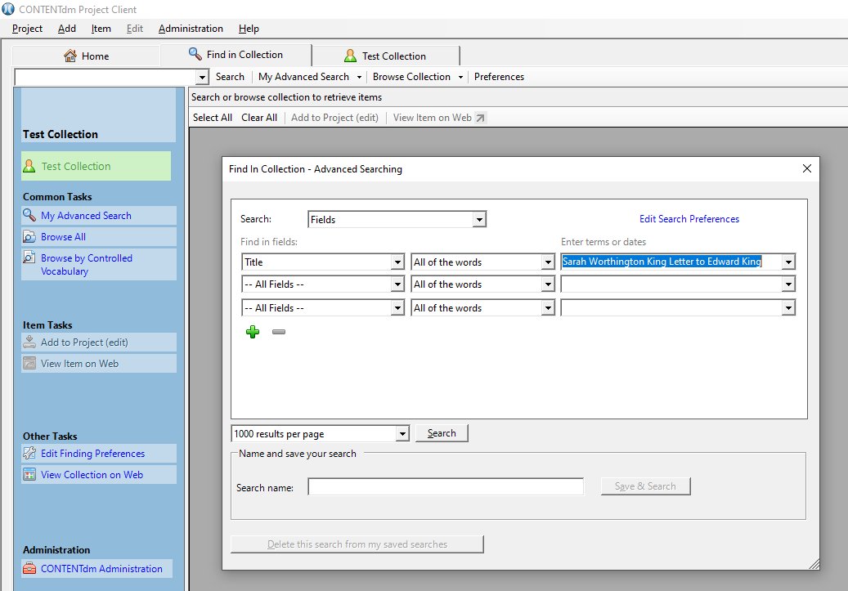

After the search, your item will display in the search results. Select the compound object item and click the “Add to Project (edit)” tab.
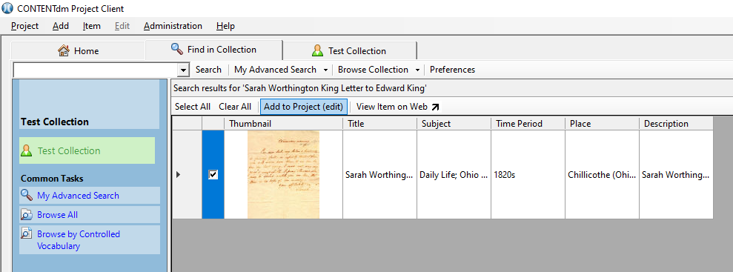
Click on the project tab for the collection and double-click the item thumbnail to view the full record.
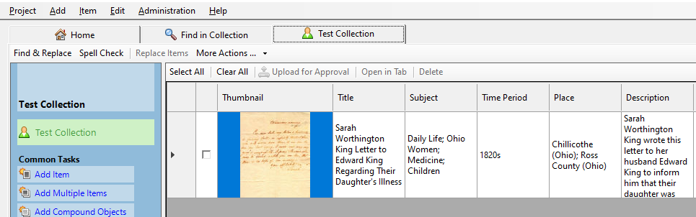
From the full record page, you can add more images to the compound object.
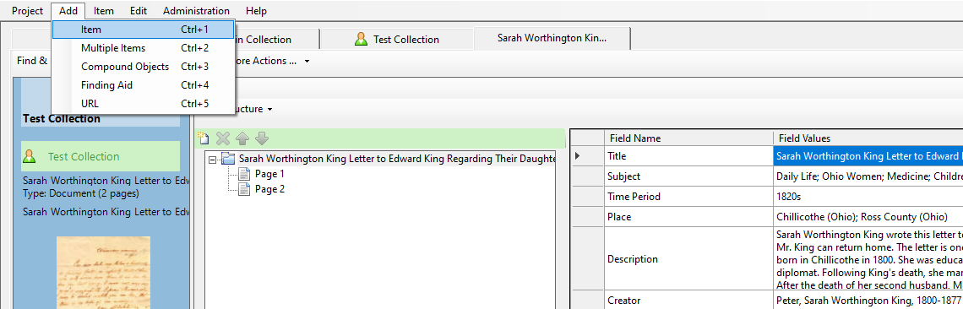

After adding, they will show up underneath the compound object in your project tab. At this point, select the new page, right click, and add the image to the compound object.
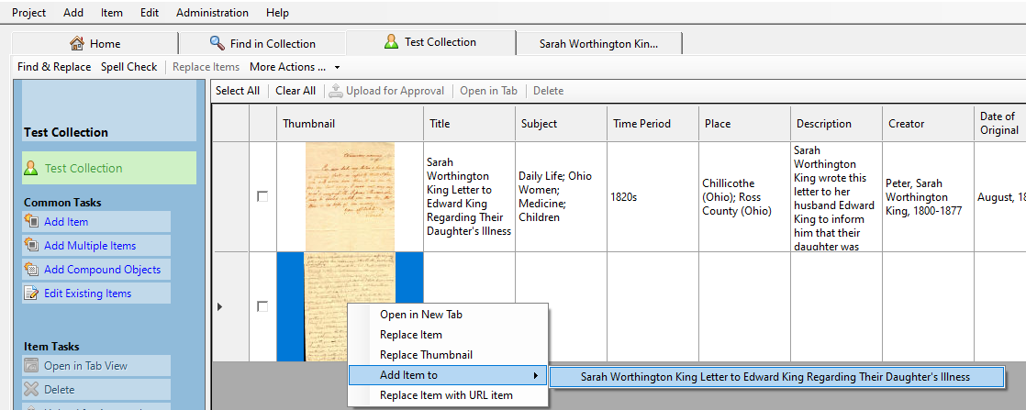

After selecting the new page, you will be given the options of moving it up or down in the sequence of pages
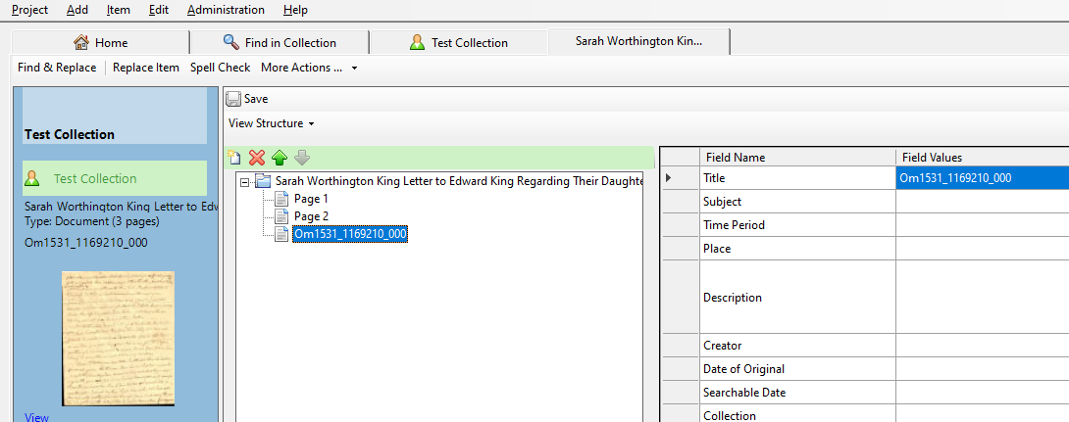

To change the label for a page, left click once on the title and re-label it.
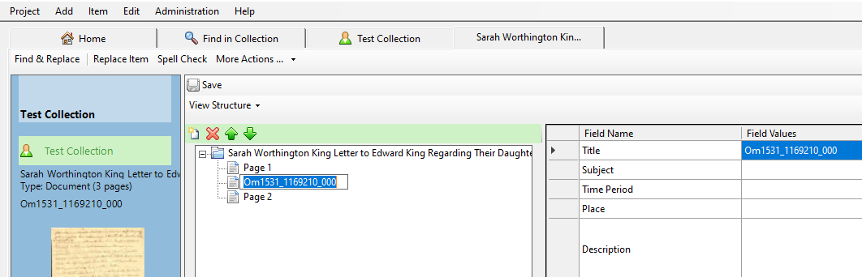

If you want to remove a page, select the page you want to remove and click the red X.
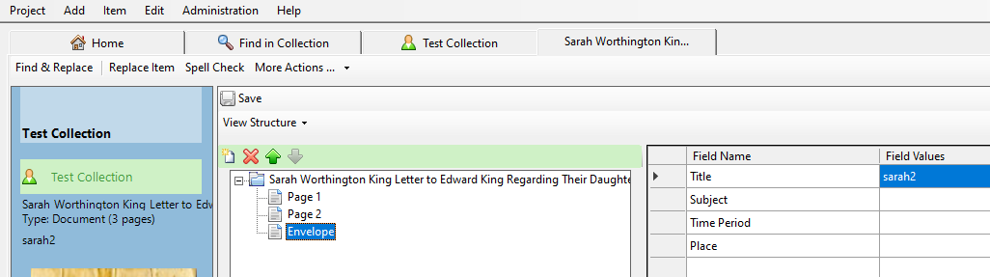

Save and close the compound object record, then upload it for approval.

