

Toledo Lucas County Public Library
Digitization Equipment Manual
Flatbed Scanner – Epson 11000XL
Last revised: January 2016

Scanning Basics…………………………………………………………………………………3
Scanner Settings……………………………………………………………………….………3
Scanning on Epson 11000XL……………………………………………………………..6

Scanning Basics
Before scanning, please read this entire document, as it contains important information about the scanning workflow and documentation.

In order to capture the clearest image possible, your scanner must be clean. Prior to scanning your documents or photographs, use a soft cloth to clean the glass top of the scanner or lens to remove debris and dirt. Check the glass surface regularly to make sure that dust from old paper and photographs is removed.

Regularly clean the lens or scanner platens, or the material on the scanner lid that presses against your documents, to ensure that it is clean and free of debris that can detract from the image quality of your scan. The scanner should be calibrated annually per the instruction of the manufacturer.

Scanner Settings
The scanner’s settings are important because they control how well the image is copied.
Listed below are some common terms that will help you determine the proper settings.

Color Mode: this refers to color palettes that will be used to copy and display your scanned image.

Color modes:

- Bitonal: a simple two-tone black and white scan. Bitonal is sometimes used with typewritten documents or printed texts that are crisp and easy to read. Bitonal is typically referred to as “black and white” in scanner settings, and it does not pick up any details in shading, such as those in photographs or hand-written documents. It is not recommended to use bitonal color mode.
- Grayscale: a palette of 256 gray shades. Grayscale is typically used with black and white photographs or documents that are not clearly scanned in a bitonal setting, such as pages with handwriting or stamped images that have shading details.
- Color: a palette of 256 to thousands of color tones, depending on your scanner. Color is typically used for scanning color or sepia photographs or documents with color (such as maps or illustrations).
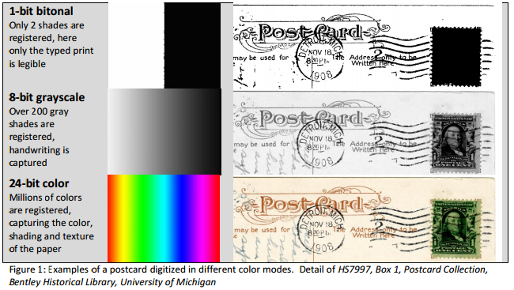

Resolution: basically the finely spaced detail of your scan in color depth and spatial resolution. Resolution is measured in bit-depth and dots per inch, or DPI.

Bit-depth: refers to how many levels of shades or colors your scan will capture, generally from 256 shades to over 65,000. Typically, black and white and grayscale images do well at 8-bit depth, and color requires 24-bit depth for extra fine resolution. This is commonly described in combination with color mode, such as scanning to “8-bit
grayscale” or “24-bit color.”

Dots per inch, or DPI: refers to how finely spaced the detail of your scan will be by
capturing a certain number of pixels per inch (also referred to as pixels per inch or PPI).
Choosing a higher setting for the DPI means the detail of your scan will be higher, so that users can zoom in to look at finer details. A higher DPI also means the size of your
digital file will be larger and your scanner will take longer to complete the digitized copy.
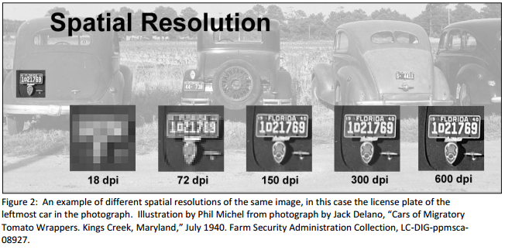

Digitization Settings: The following settings are recommended for common image sizes and types. These have been developed to be accessible targets. It is highly recommend to adhere to the minimum resolutions outlined in the table below and to scan all photographs regardless of whether they are sepia, black/white or color in 24-bit color mode.

Original Material | Scan Resolution & Color Mode
Photographs | 24-bit color
8 x 10” print | 600 dpi preferred, 300 dpi minimum
4 x 6” print or smaller | 800 dpi preferred, 400 dpi minimum
Textual Documents | 24-bit color, 8-bit grayscale minimum
8.5 x 11” office paper | 400 dpi preferred, 300 dpi minimum
4.5 x 6.5” card stock size or smaller | 400 dpi preferred, 300 dpi minimum

Note: Unusual sizes such as photographic negatives or panoramas, which are very rectangular, need special consideration when scanning. To achieve the desired spatial resolution, you must measure the size of the original and obtain the size of the longest edge. Special items such as these are recommended to capture at 5,000 pixels across the long dimension while maintaining a minimum of
300 dpi.

Example calculations:
A 2” x 3” photograph: 5000 pixels divided by 3 = around 1667, thus the dpi setting would be 1600 dpi.
A 1” x 4” negative: 5000 pixels divided by 4 = 1250 dpi.
A 5” x 25” panorama: 5000 pixels divided by 25 = 200 dpi, instead keep the 300 dpi minimum or opt for 600 dpi.
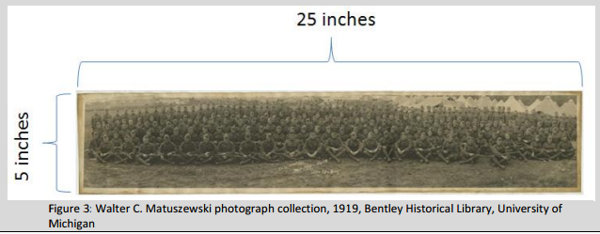
Figure 3: Walter C. Matuszewski photograph collection, 1919, Bentley Historical Library, University of Michigan

These spatial resolutions can be particularly high, and may be outside of the reach of your scanning equipment’s technical capacity or may be demanding on your computer’s system.

______________________________________________________________________________

Scanning on the Epson 11000XL
- Turn the scanner on

- Open Epson Scan
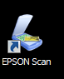

- This window will pop up:

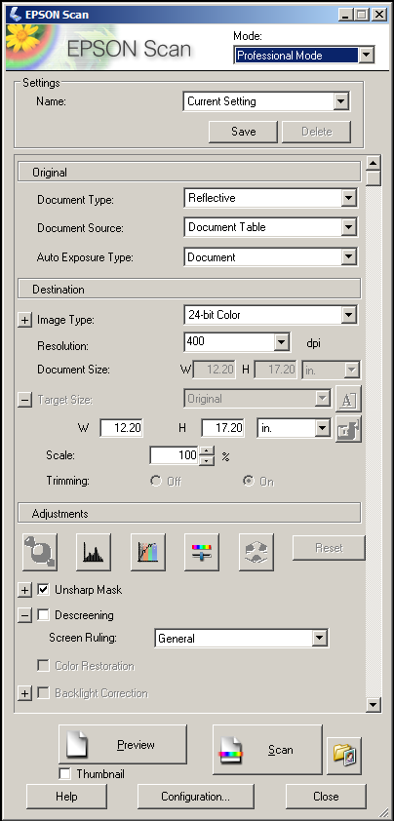

- Set item on scanner and make sure to place it in the upper left hand corner, opposite the white triangle.

- Make sure that the white backboard is on the scanner.

- For photos, please make sure that the following settings are selected:
Document Type: Reflective
Document Source: Document Table
Auto Exposure Type: Photo
Image type: 24-bit color
Resolution: 600 dpi

- For documents, please make sure that the following settings are selected:
Document Type: Reflective
Document Source: Document Table
Auto Exposure Type: Document
Image type: 24-bit color
Resolution: 600 dpi

- For film and negatives, make sure to remove the white backboard and then select the following settings:
Document Type: Film
Document Source: B&W Negative Film, Color Negative Film, or Positive Film
Image type: 24-bit color
Resolution: 600 dpi

- Next, click Preview.
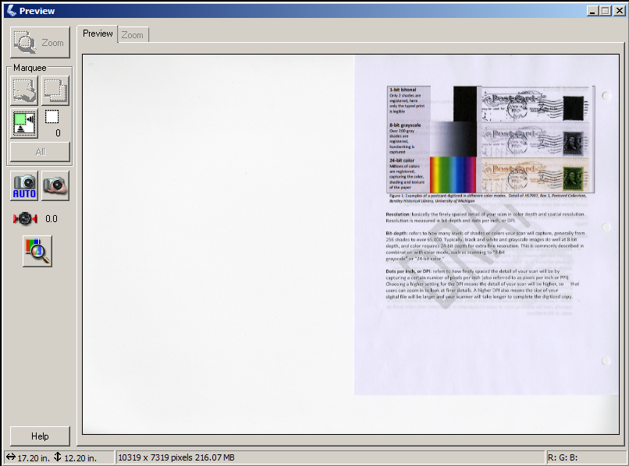

- Select the area you want to scan.
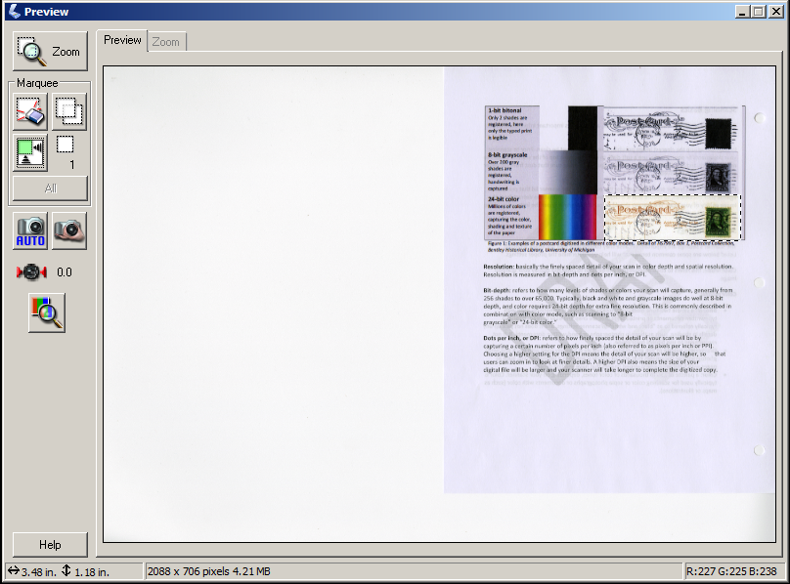
- Leave excess space around the border of the item, if deskewing is necessary.

- Click Scan.

- The File Save Settings window will pop-up:

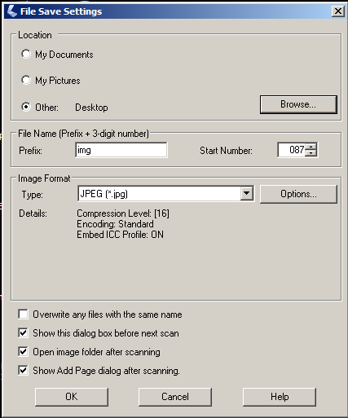

- Click Other and Browse to navigate to the proper folder on the image server.

- Create file name Prefix following the file name guidelines. (See Workflows & Tasks Manual for more information.) Start Number should be 001. Make sure that TIFF is selected as the Type.
Example:
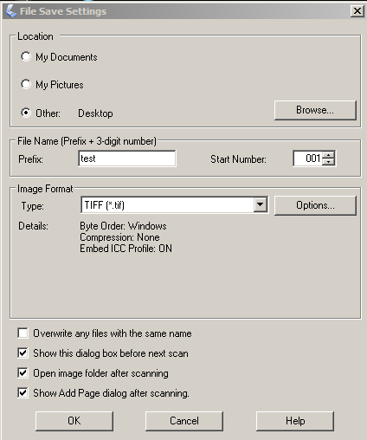

- Click Ok.

- Image will appear in the directory that you saved it to.

- Repeat for all items in collection.

- When done scanning, turn off the scanner.

- Once the files have been uploaded to the image server, be sure to record how long it took you to edit the files on the Intranet or let the DSS know via email.

- Ask Digitization Services Supervisor if you have any questions.

